**Steps to access the power bi working environment**

Use the username and password provided

Click on the three dots and click on power on

c

You will get the connect button enabled click on connect

If required refresh this page to connect button is taking some time to enable

Click on connect button

Please one or two minutes to power on the machine

Your environment will be opened

You can see the power bi icon on the desktop

From the screen shot you can see the power bi folder this where your assessments files are you will need to complete all the tasks and save all the file in the respective folder .

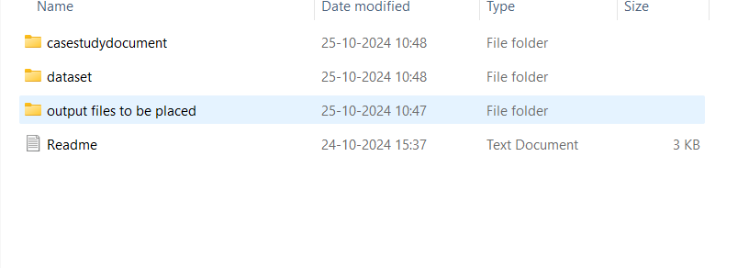

• **File Organization:**

* **Case Study File Folder:** This folder contains the question files you need to refer to for solving the case study.
* **Dataset Folder:** This folder contains the dataset files in .csv format. You will use these for data analysis.
* **Output Files to Be Placed Folder:** This is where you need to save your output files, including:
  + Power BI files (.pbix).
  + CSV files with the output data.
  + Images of visualizations created.
  + Queries used in the analysis (to be documented in a separate file or inside the document).

• **Readme File:** The readme file provides hints and guidance to help you solve the problems.

**Output Files to Be Placed Folder:**

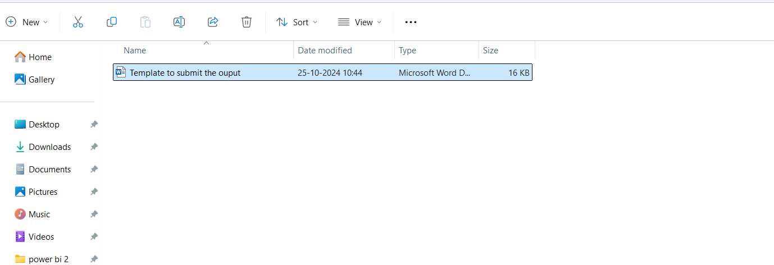

If you open the file you can see the place where you must place your name and email address and submit the images and queries used which implementing power bi

Save the file .

Your final output submission should look like this implementation file should saved inside the folder

The power pi file ,charts and graphs and the csv files and template document file must be updated and saved

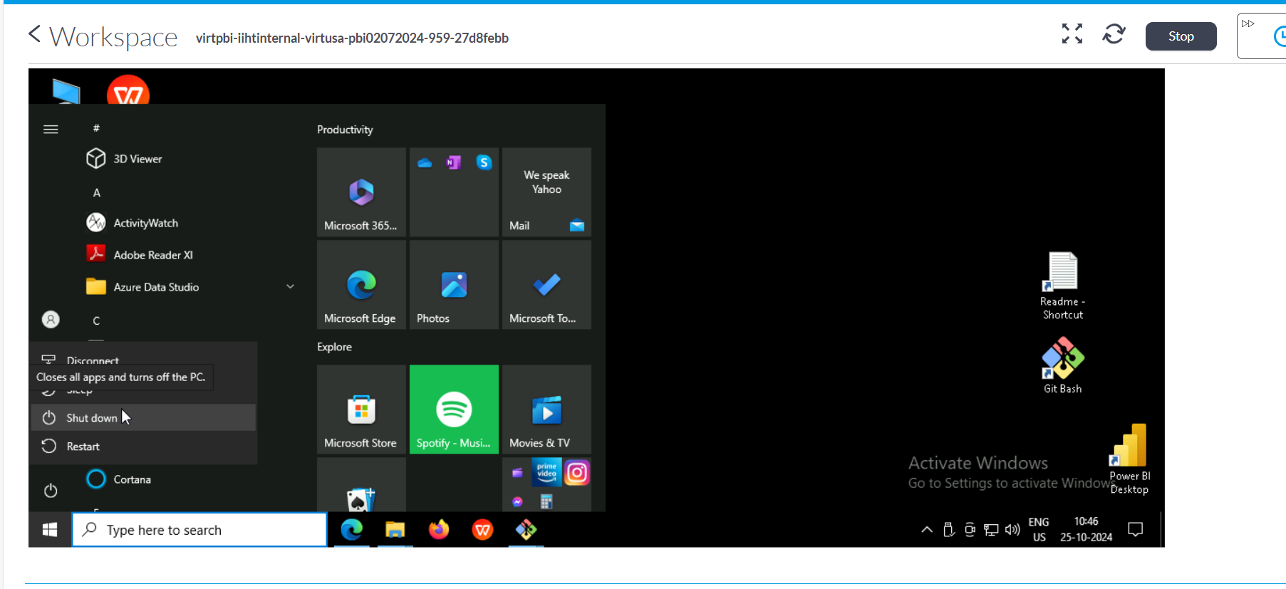

Save your work and shutdown the virtual machine .